OFFICE ORDER FOR NON-TRAVEL ACTIVITIES

No. <<NTARF #>>, s. 2026

TO: <<Involved WPU Personnel (Position)>>

You are hereby <<Final Approval>> to be involved in the <<Activity Requested>> on <<Date of Activity>> TO <<Date of Activity End>> (<<Time of Activity Start>> - <<Time of Activity End>>) as <<Type of Involvement>>.

Please be guided accordingly.

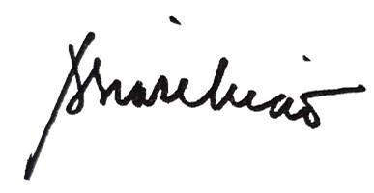

Amabel S. Liao, PhD
University President

